MACHINE LEARNING :D :!!! LESSSS GOOOOOOOOOOOOOOOOO

=====NOTES=======

Vid 1: What is ML? and its major stuffs

Machine learning are of 3 types:

1. Supervised
2. Unsupervised
3. Reinforced

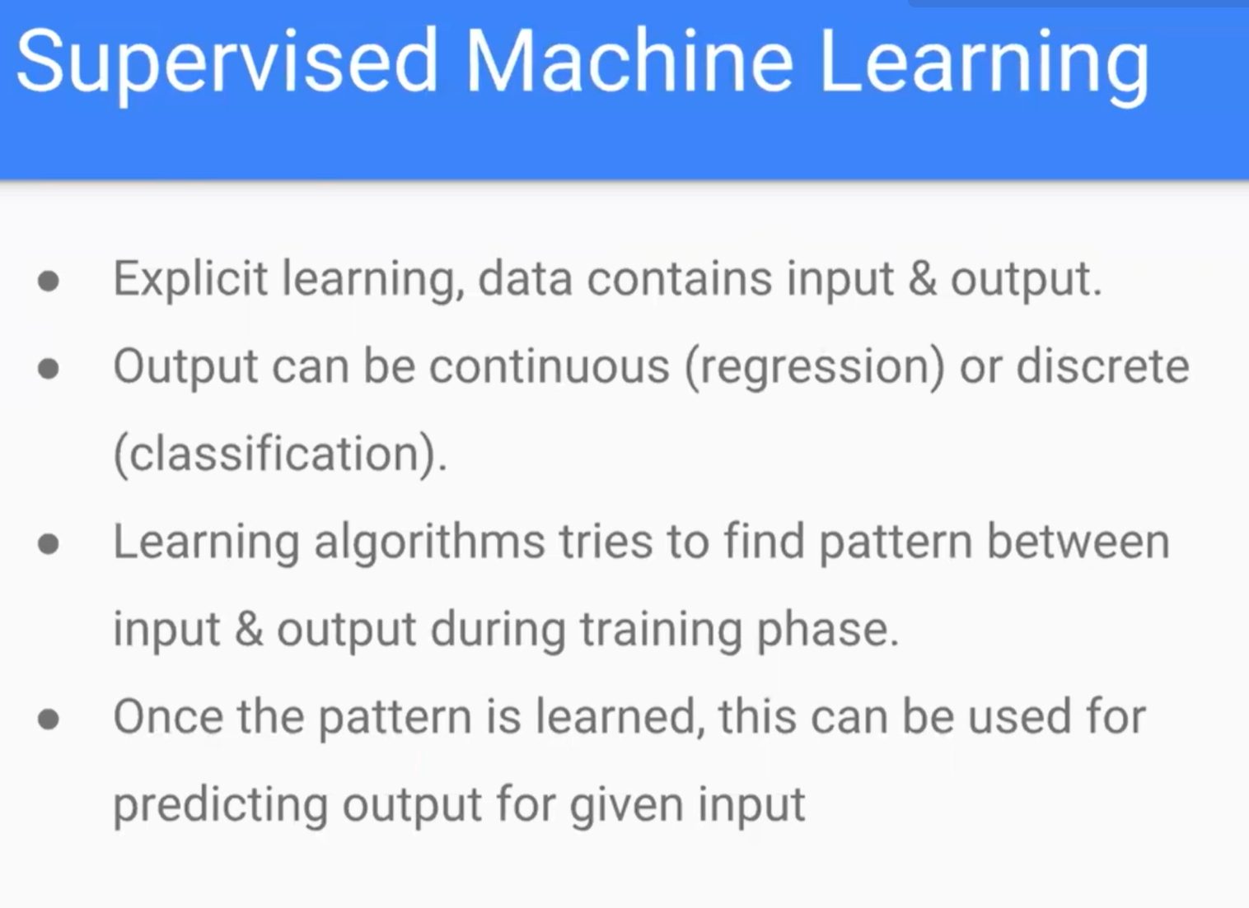

Eg we give it lots of dog pics and tell the model its dogs

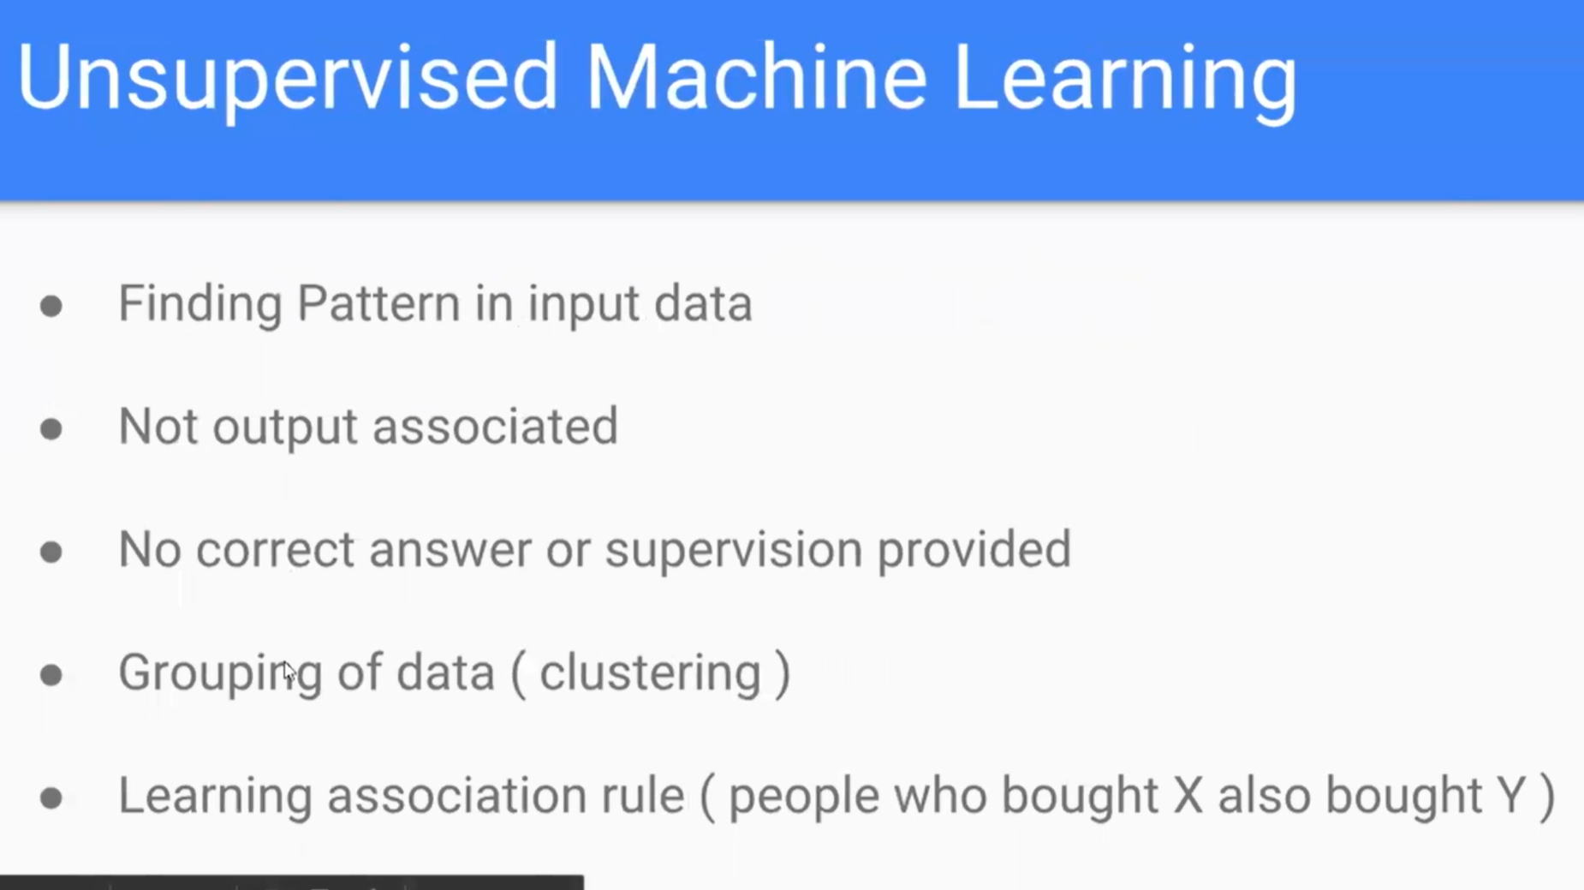

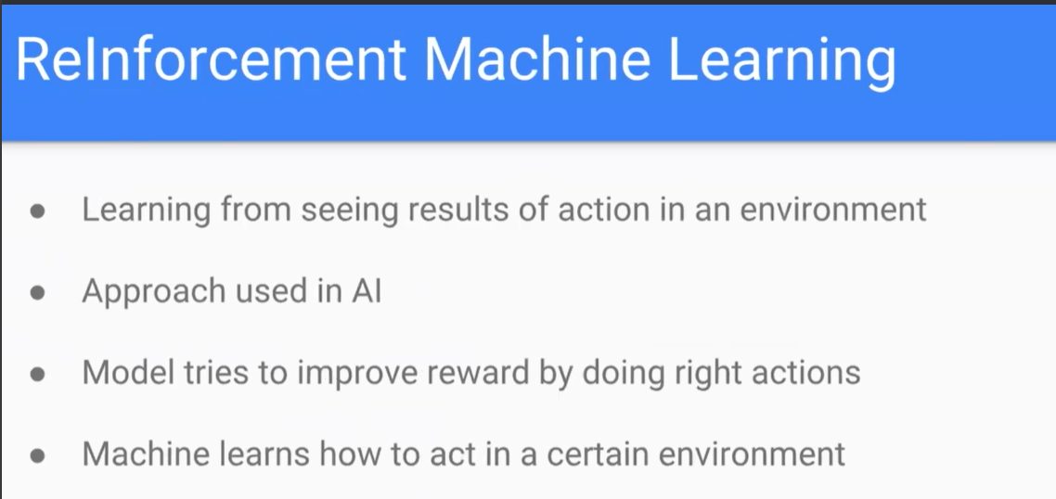

Reward based learning: when model does something good its rewarded

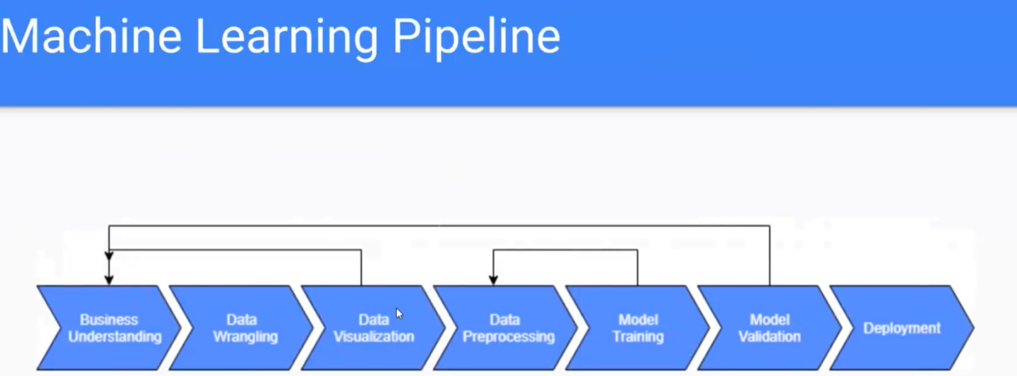

Feature Extraction:

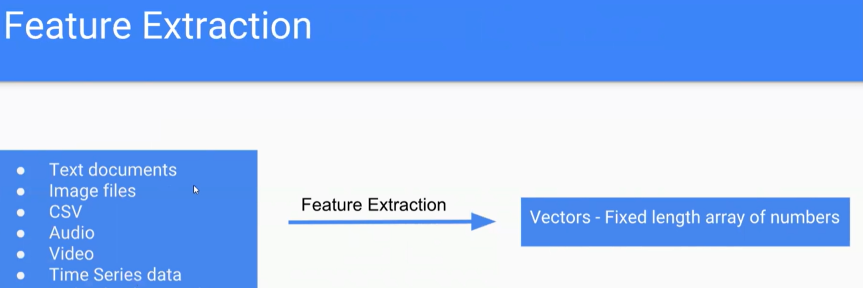

VID 2:

Numpy :

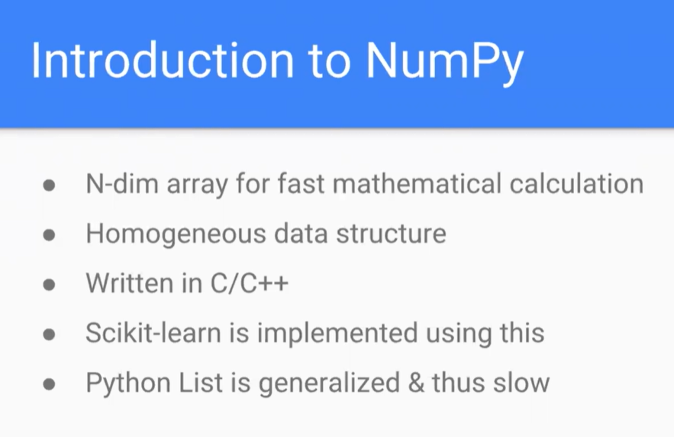

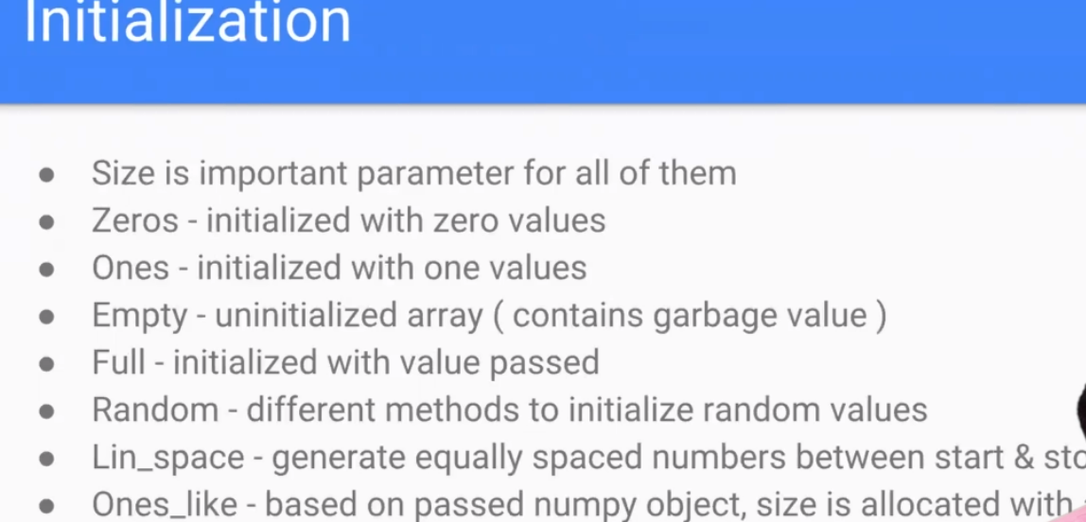

To generate 3x3 matrix which initialized to 1

Pass size as tuple (2,2) , (2,3)etc

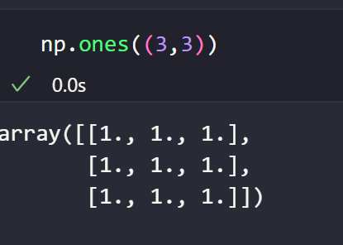

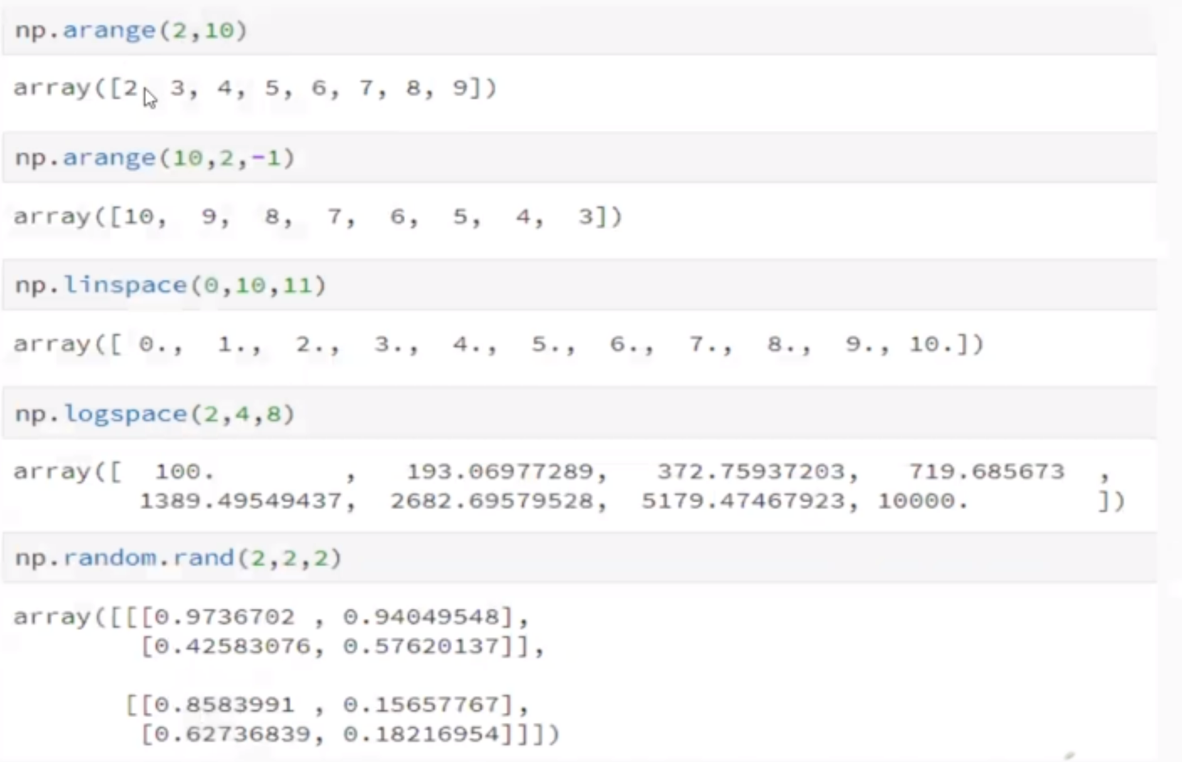

// here np.linspace(I,j,k) generates i->j numbers with k divisions

And np.logspace(I,j,k) ) generates 10^linspace ka ans numbers with k divisions

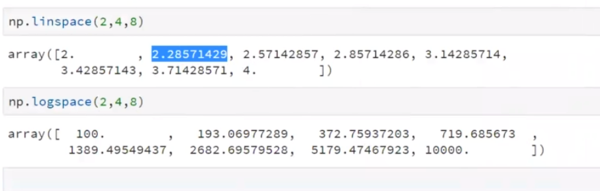

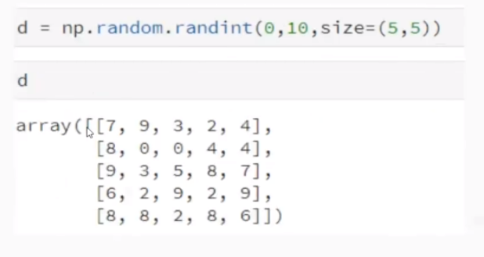

Here np.random.randint(I,j,size(m,n)) generate number between i->j in matrix of size mxn

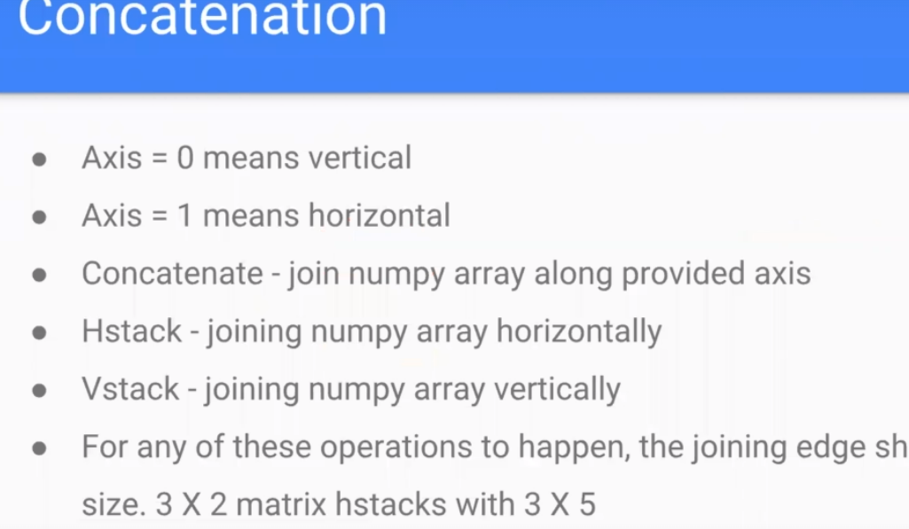

np.concatinate([a,b],axis=1)

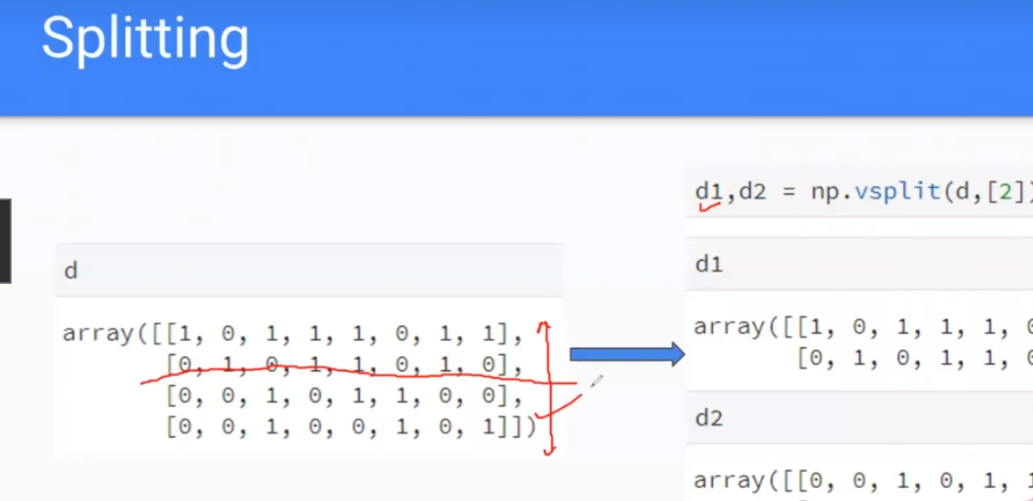

Here np.vsplit(d,[2]) splits matrix into two parts, vsplit does vertical split , hsplit for horizontal

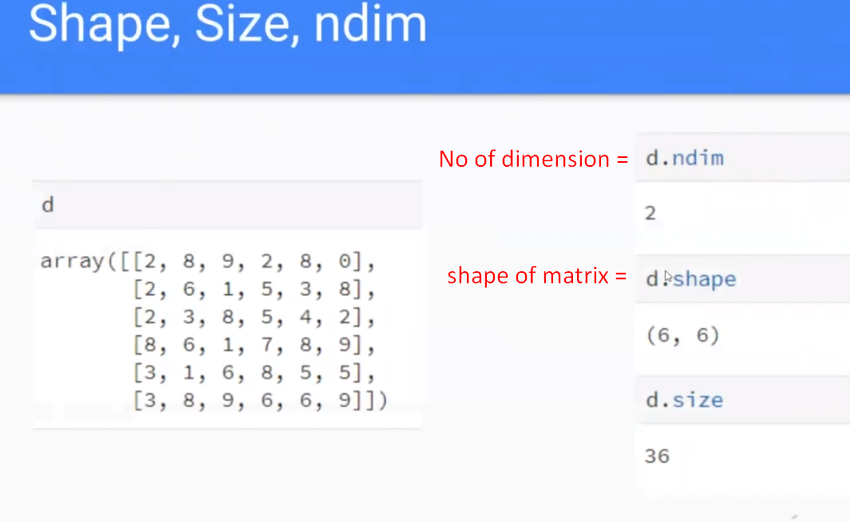

Reshaping …………..

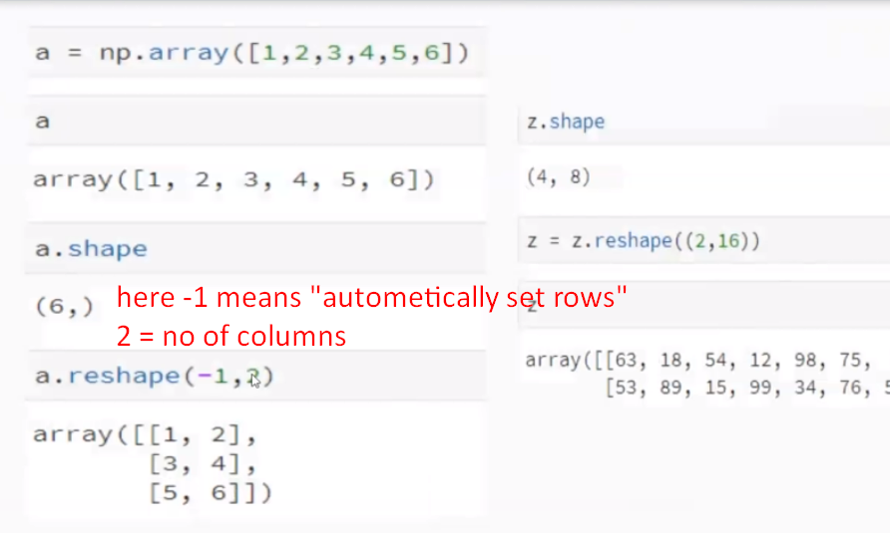

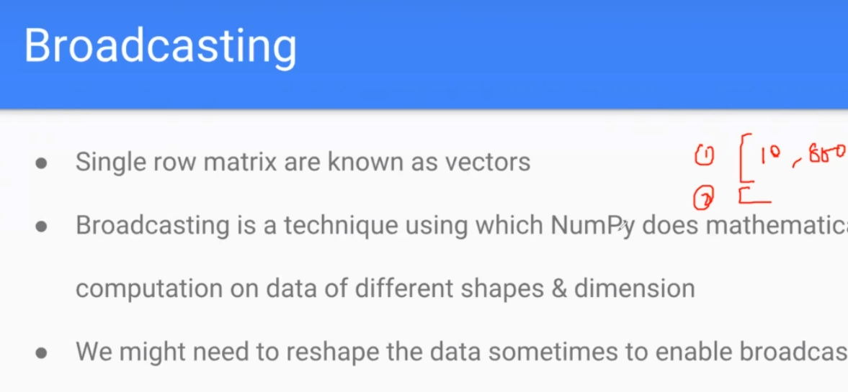

Addition of different size of matrix to a matrix with DIMESION ONE (LIST)

